Resume
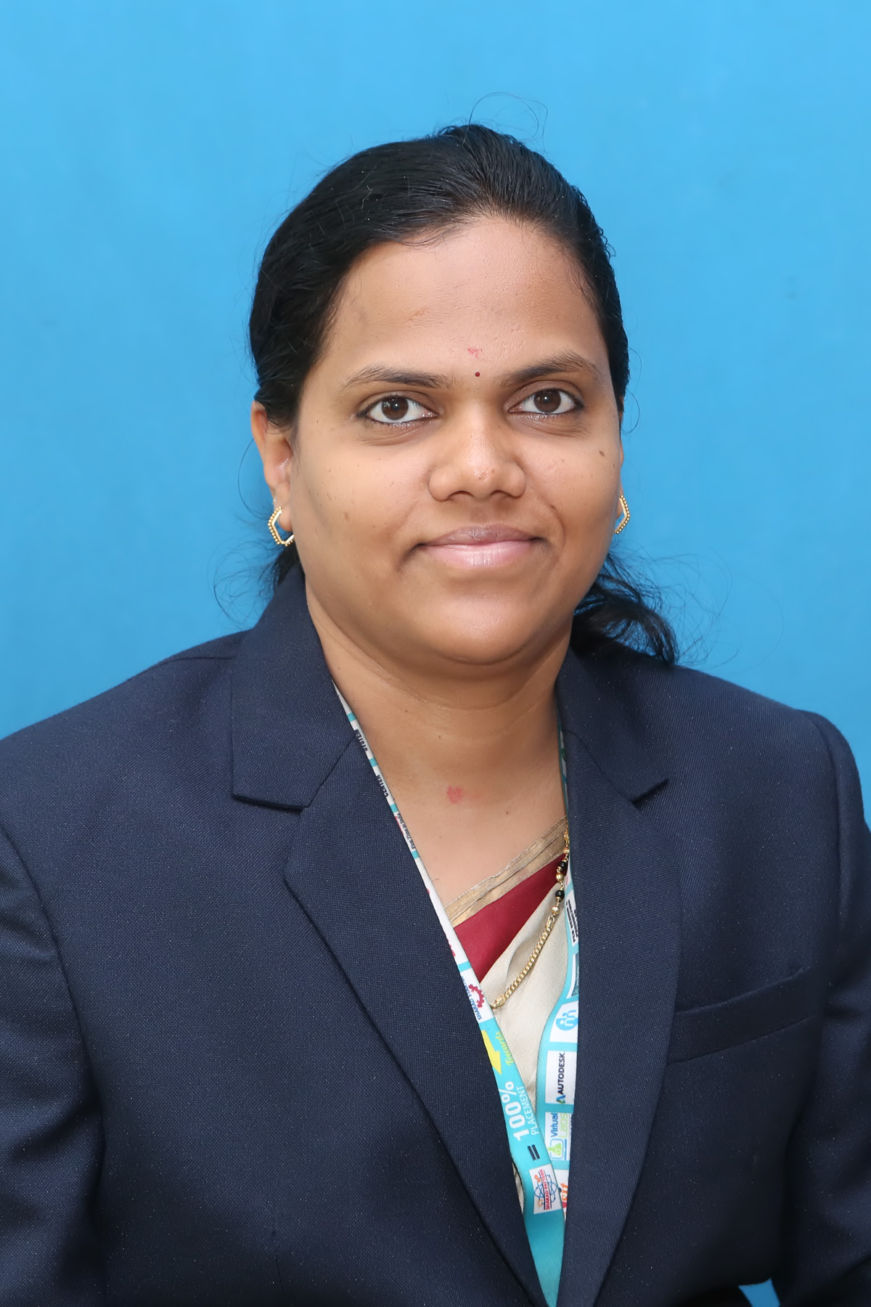
Personal Data:
Title (Mr/Ms./Mrs./Dr./Prof.) | Ms.
Name | Priya Dilip Ghate
Program (UG/PG) | UG
Course / Department | Electronics and Telecommunication
Area of Specialization | Communication
Exact Designation | Assistant Professor and Dean Faculty Development
Address (Residential)  (with PIN code) | ‘Arpan’apartment behind hotel Shivechha opposite market yard Sangli.416416
E-mail ID | priyadghate@gmail.com
Mobile No. | 8485874858

- Project Under Taken:
Sr. No. | Name of the Project | Academic Year
1 | Acoustic Blind Library. | 2014-15
2 | Multitasking Home Security System | 2014-15
3 | IVRS based calling system | 2014-15
4 | Transformer coiling system | 2013-14
5 | Material handling using pneumatic pressure and conveyor belt control by using PLC | 2013-14
6 | Smart Bus System | 2015-16
7 | GSM based garbage waste management system | 2015-16
8 | Fracture Recovery System by stacking the assembly automatically | 2018-19
9 | IOT Based Cloth Process Control System | 2019-20
10 | Water Leakage Detection & Monitoring System using IOT | 2019-20
11 | Smart Wheel Chair | 2020-21
12 | Mistery Mirror | 2020-21
13 | Water quality monitoring system | 2021-22
14 | Automatic solar powered grass cutter | 2021-22
15 | Automatic path finding robot | 2022-23
16 | An approach to design a pupillometer for early detection of diabetes using Raspberry-Pi | 2022-23
17 | Smart Intelligent vehicle accident message system for emergency medical assistance | 2022-23
18 | Soldier Health monitoring and position tracking system | 2022-23
19 | Maximum power point presentation using ML/IOT | 2022-23

- Academic Qualifications:
Exam Passed | Name of the institute | Name of the board/university | Mode  Regular/Distance | Year of passing | % of Marks Obtained or Grade | Class/Division/Grade/Merit etc. obtained
Diploma | PVPIT Budhgaon | Shivaji University Kolhapur | Regular | 2006 | 70.52% | Distinction
Degree  (U.G.) | PVPIT Budhgaon | Shivaji University Kolhapur | Regular | 2009 | 68.19% | Distinction
P.G. | RIT Sakharale | Shivaji University Kolhapur | Regular | 2012 | 71.22% | Distinction
Ph.D. | MIT,Pune | World Peace University,Pune | Part time | 2021 | CGPA:9.50 | persuing
Others | - | - | - | - | - | -

- Experience:

Teaching Experience  (In Years) | Professional / Industrial Experience(In Years) | Research Experience  (In Years)
12.5Years | - | -

Experience Details:

- Worked as a Lecturer in Latthe Polytechnic, Kupwad from May 2010 to April 2011.
- Worked as a Lecturer in Padmabhooshan Vasantrao dada Patil Institute of Technology,
Budhgaon from July 2011 to April 2012.
- Working as an Assistant Professor and Academic Coordinator in Sharad Institute of Technology college of Engineering Yadrav, from 6th October 2017 to 6th June 2019.
- Working as an Assistant Professor and Program Coordinator in Sharad Institute of Technology college of Engineering Yadrav, from 7th June 2019 to 24th March 2021.
- Working as an Assistant Professor and Dean Faculty Development in Sharad Institute of Technology college of Engineering Yadrav, from 29th April 2021 to till date.
- Nominated as Member of Local Committee from 18th August 2018 to till date.
- Worked as a Judge for Poster Presentation in Computer Science Engineering Department SIT COE Yadrav on 15th October 2020.
- Worked as a Judge in National Level Project Competition(TECHNOKRAT 2021) in SIT Polytechnic Yadrav on 5th June 2021.
- Worked as a judge in Nurse’s Week Celebration in Sharad College of Nursing Yadrav, Ichalakaranji.
- Worked as NSS coordinator in SIT COE Yadrav.
- Working as PG Coordinator in Sharad Institute of Technology college of Engineering Yadrav, from June 2021 to till date.
- Worked as paper Setter for Third Year End Semester Examination
- Working in Institute Exam Lapses Committee from AY 2021-22.
- Arranged Non Teaching Faculty Development Program arranged on “Trouble shooting and Maintenance” on 8th Sept 2021 to 13th Sept 2021.
- Arranged One Week Online Faculty Development Program on “Simulation Tools for Research” approved by ISTE New Delhi On 7th February to 12th February 2022.
- Visited “ISRO” Bangalore on 11th May to 15th May 2022
- Worked as IEEE department coordinator, and two groups got prize for Short video contest based on Women Personality of their region on the theme that “SHE: Share Her Experience” organized by IEEE Women in Engineering Affinity group,Bombay Section on 20th July 2022.
- Worked as a E-yantra Innovation Lab Coordinator.
- Arranged One Week Faculty Development Programme on “Python, Data Science and Machine Learning” approved by ISTE New Delhi on 19th July 2022 to 23rd July 2022.
- Workshop Arranged for 800 girls student in SIT COE and in association with Bhartiya Jain Sanghatana from 17th August to 18th August 2022.
- Workshop Arranged for 450 girls student in SIT COE and in association with Bhartiya Jain Sanghatana from 2nd August to 5th August 2023.

- Conferences, seminars, symposia, training, workshop, STTP, FDP attended

Sr. No. | Name of the conferences/ seminars/symposia /STTP/FDP/workshop | Name of sponsoring agency | Duration |  | Place
Sr. No. |  | Name of sponsoring agency | from | to | Place
1 | Training Programme for Teaching Faculty | Electronics and Telecommunication Dept.  PVPIT, Budhagaon  Sangli India – 416 416. | 18th Feb2012 | 18th Feb2012 | PVPIT, Budhagaon
2 | Impowerment of Women in Science & Technology | General Engg. Dept.  PVPIT, Budhagaon  Sangli India – 416 416 | 31st March2012 | 31st March2012 | PVPIT, Budhagaon
3 | Solar concentrating collector | SIT COE Yadrav,Ichalkaranji. | 22nd to March 2013 | 23rd March 2013 | SIT COE Yadrav
4 | Better enhancement of soft skills and Techniques for teaching faculty. | SIT COE Yadrav,Ichalkaranji. | 17th to December  2012 | 27th December  2012 | SIT COE Yadrav
5 | Workshop on “Solar Concentrating Collector” | SIT COE Yadrav,Ichalkaranji. | 22nd to March 2013 | 23rd March 2013 | SIT COE Yadrav
6 | National Level Workshop on “Network Simulator2 for wired & Wireless Network organized by E & TC Dept. | SITP Yadrav | 17th to October 2013 | 19th October 2013 | SITP Yadrav
7 | University Level Technical Event Master Presenter 2K12 organised by E & Tc dept | SIT COE Yadrav | 14th Sept 2012 | 14th Sept 2012 | SIT COE Yadrav
8 | Natinoal Level Event Master Presenter 2K13 organised by E & TC Dept. | SIT COE Yadrav | 30th Sept 2013 | 30th Sept 2013 | SIT COE Yadrav
9 | ISTE-SRM Short Term Training Programme on “Advanced Trends in Video 10Engineering”organized by E & TC Dept sponsored by Indian socity for Technical Education,New Delhi and SRM University,Chennai | SIT COE Yadrav | 12th to May,2014 | 16th May,2014 | SIT COE Yadrav
10 | “Measurement Techniques in RF Agilent Technologies”organized by E & TC Dept.in collaboration with Procom Enterprises and Technofield solutions | Bharti Vidyapeth’s COE,Kolhapur | 16th July 2014 | 16th July 2014 | Bharti Vidyapeth’s COE,Kolhapur
11 | ISTE Workshop on “Control Systems” conducted by Indian Institute of Technology Kharagpur. | SIT COE Yadrav | 2nd to December,  2014 | 12th December,  2014 | SIT COE Yadrav
12 | ‘Final Year Syllabus” Formation of BE(E & TC)at Dept of E & TC | AMGOI Vathar Tarf Vadgaon. | 9th February 2015 | 9th February 2015 | AMGOI Vathar Tarf Vadgaon
13 | ISTE STTP on “Introduction to Design of Algorithms conducted by Indian Institute of Technology Kharagpur.  It was held under the Nationa Mission on Education through ICT(MHRD) | SIT COE Yadrav | 25th to May,2015 | 30th May,2015 | SIT COE Yadrav
14 | “Advanced Trends in Research Methodology”sponsored by ISTE | SIT COE Yadrav | 15th to June 2015 | 26th June 2015 | SIT COE Yadrav
15 | “Advanced trends in PLC “ | SIT COE Yadrav | 30th Nov to 2015 | 4th Dec 2015 | SIT COE Yadrav
16 | Faculty Development workshop on”GUI Design and ARDUINO Interfacing in MATLAB organized by E & TC Dept under SUK-LEAD college activity | SGI,Atigre | 17th to December,  2015 | 18th December, | SIT COE Yadrav
17 | Pedagogy to Synergogy(FDP) | SITCOE,Yadrav | 31st December 2015 to | 4Th January 2016 | SITCOE,Yadrav
18 | Recent Trends in Internet of things | SITCOE,Yadrav | 6th June | to 11th June 2016 | SITCOE,Yadrav
19 | " Orientation Program on Outcome Based Education" | One Week FDP, Organized by ETC Department, SITCOE | 30th Oct 2017 to | 04th Nov 2017 | SIT COE Yadrav
20 | Outcome Based Education | SIT COE Yadrav | 21st May to | 26th May 2018 One Week  2018 | SIT COE Yadrav
21 | Foundation program in ICT for education | IIT Bombay | 13th Sept 2018 | 18th October 2018 | AICTE Approved
22 | FDP on “Python Programming” | SIT COE Yadrav | 3rd October to | 8th October 2018 | SIT COE Yadrav
23 | Pedagogy for online and Blender Teaching –Learning Process | IIT Bombay | 30th October 2018 | 13th December 2018 | AICTE Approved
24 | FDP on Product Design Engineering | AMGOI Vathar | 20th December 2018 | 24th December 2018 | AMGOI Vathar
25 | C and C++ | SIT COE Yadrav | 29th February 2020 | - | SIT COE Yadrav
26 | “Machine Learning and deep learning hands on experiments using python” | SIT COE Yadrav | 1-6-2020 | 9-6-2020 | SIT COE Yadrav
27 | FDP on “Artificial Intelligence” | Online | 7th Dec to 2020 | 11th Dec 2020 | Online mode
28 | “Machine Learning and Its applications” | SIT COE Yadrav | 16th March 2021 | 20th March 2021 | SIT COE Yadrav
29 | “Introduction to Machine Learning” | Sinhgad Institute of Technology Lonavala. | 18th April 2022 | 22th April 2022 | online
30 | Webinar on “Role of IEEE in Engineering Education” | SIT COE Yadrav | 21st May 2021 | - | SIT COE Yadrav
31 | “Research Methodology, Research Publications and Patent Filling” | SIT COE Yadrav | 20th Sept 2021 | 24th Sept 2021 | SIT COE Yadrav
32 | ‘Simulation Tools for Research” | SIT COE Yadrav | 8th Feb 2022 | 14th Feb 2022 | SIT COE Yadrav
33 | FDP on “ NBA Accreditation and Teaching and Learning in Enginerring” | NPTEL Online Certification | Jan | April 2022 | -
34 | One Week faculty Development Program on “Effective Research Paper and Proposal Writing” | SIT COE Yadrav | 4th January 2023 | 8th January 2023 | SIT COE Yadrav
35 | One Week Short Term Course on “Computational Intelligence Technologies and Applications”(CITA-2023) | SIT COE Yadrav | 3rd June 2023 | 8th June 2023 | NIT Kurukshetra,Haryana

- Paper Publication
1 | Detection and Labeling of Vertebrae using Deep Learning | International Journal of Recent Technology and Engineering (IJRTE) | ISSN: 2277-3878, Volume-9 Issue-1, May 2020
2 | IoT Based cloth Process Control System | IJETCS | Volume-5 Issue-2, May 2020
3 | Water Leakage detection Monitoring and controlling system using IoT | IJETCS | Volume 5 Issue 2 June-2020
4 | Emerging Steps in Mobile Network 5G to 7G: Review | IJRAR | Vol 6,Issue 2,  2019
5 | Enhancement of RVM Using FPGA | JARDCS | Vol 11,  2019
6 | Automatic Fracture Recovery and Limb Lengthening system using Ilizarov | MAT Jornals | Journal of Telecommunication study Vol 4,Issue 1 2019
7 | Detection of Routing Misbehavior in MANETs using 2ACK Approach | NCRTI,PVPIT bughgaon | NCRTI,PVPIT bughgaon
8 | 2 ACK Based Routing Misbehavor Detection in Ad Hoc Networks Using NS2 | NCRTI,PVPIT bughgaon | NCRTI,PVPIT, Budhgaon

- Invited talks/Expert Lectures delivered:-

Sr. No. | Name of Faculty Member | Award/ Achievements | Award Details | Place | Date
1 | MS P D Ghate | Expert Lecture on Basic Electronics | CSE Students for Campus (Aptitude) | SIT COE Yadrav | 25th Sept 2018
2 | MS P D Ghate | Expert Lecture on Basic Electronics | Under E –Yantra Competition,(For Mechanical,CSE,E&Tc students) | SIT COE Yadrav | 21st-22nd Sept 2018

- Industrial Training:-

- One day industrial training at “Ratanath industry on 29th nov 2018

- One day industrial training at “Ratanath industry on 15th December 2017.

- One day industrial training at “Dualtek on 15th February 2022.

- One day Industrial training at Anshuman Tech Pvt.Ltd Pune on 5th April 2023.

- Extra Curricular Activities:

- Participated and worked as a Volunteer in Cervical Cancer Screening Camp on 20th August 2017 in SITCOE Yadav
- Participated in Shardotsav2k22 and Winner in Cricket
- Participated and worked as a Volunteer in Mega Health Camp arranged on 5th May 2022 in Kavathe Guland.
- Participated and worked as a Volunteer in Mega Health Camp arranged on 5th May 2023 in SIT COE Yadrav.

- Professional Membership:

Sr. No. | Name of the membership | Membership no. | Type of membership (annual / life) | Name of membership body | duration
 |  |  |  |  | from | to
1 | ISTE | LM 84752 | Lifetime | ISTE | Academic Year 2013 | Lifetime
2. | IEEE | 98051189 | - | Active IEEE Member | January 2022 | December 2022

Place:

Date:
Signature of Candidate

